Objectives:

* To know about HTML, CSS, JAVASCRIPT, PHP and their proper implementation in project.
* To be familiar with sessions and cookies in PHP and their working process.
* To develop a website about School Management System and also add database for that project.

Introduction:

A website is a collection of web pages and related content that is identified by a common domain name and published on at least one web server. It is developed with HTML, CSS, HTML, CSS, Bootstrap, JavaScript PHP etc. Session cookies **allow websites to remember users within a website when they move between web pages**

Project Details:

My project is School Management System. It is a website where people can teach from best teachers through online. There are many subjects that one’s learn by enrolling it and have to be pay a little amount of money. Admin will allow the students who want to learn through online. There are two panel in my website one is Admin and another is Student.

Features:

Admin:

* Managing User Accounts
* Managing Classes and Subjects
* Managing Class Routine
* Managing Accounts

Student:

* Manage Classes
* Manage Class Routine
* Fee Details
* Study Materials
* Communication

And all the information are stored in sms_project1 database.

There are six table:

1. Accounts

2. Classes

3. Courses

4. Metadata

5. Posts

6. Sections

In account table all the account details (id, type, email, and password) will be stored. In classes, courses and sections table information of classes, courses and section information will be stored.

The web pages that are used in the project

1. actions

* login.php
* student-registration.php
* success.php

1. admin

* ajax.php
* classes.php
* courses.php
* dashboard.php
* footer.php
* header.php
* periods.php
* sections.php
* sidebar.php
* student-fee.php
* subjects.php
* timetable.php
* user-account.php

1. includes

* config.php
* functions.php

1. student

* dashboard.php
* fee-details.php
* footer.php
* header.php
* periods.php
* sidebar.php
* timetable.php

1. footer.php
2. header.php
3. index.php
4. login.php
5. logout.php
6. student_details.php

Schema Diagram:

SQL Database:

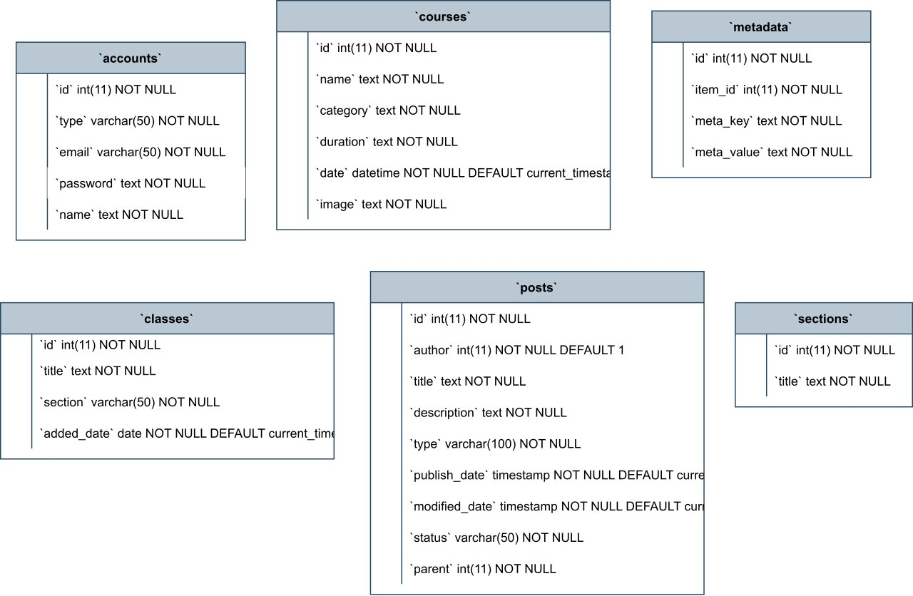

Fig 1.1: Tables of School Management System

Flow chart:

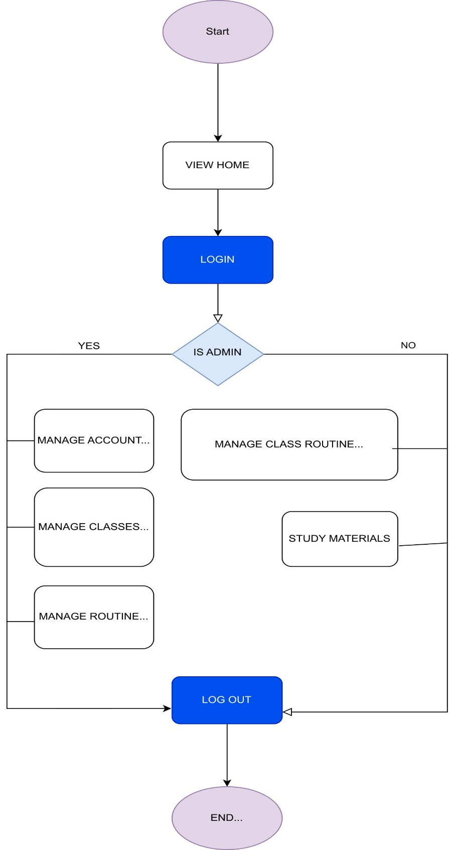

Fig 1.2: Flow chart of School Management System

Detailed visualization:

Home page:

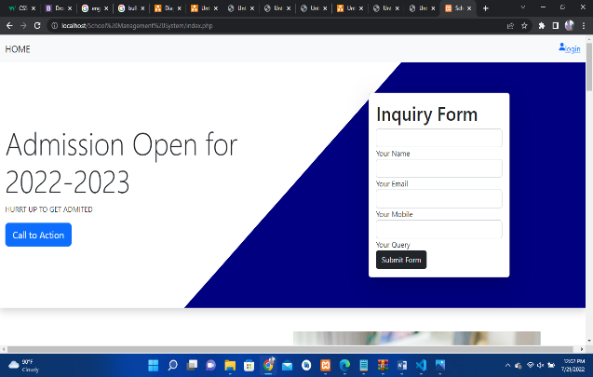

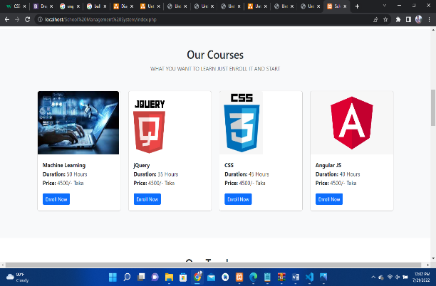 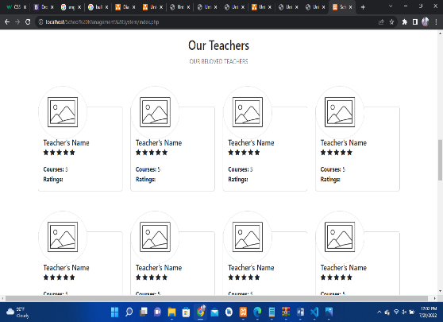

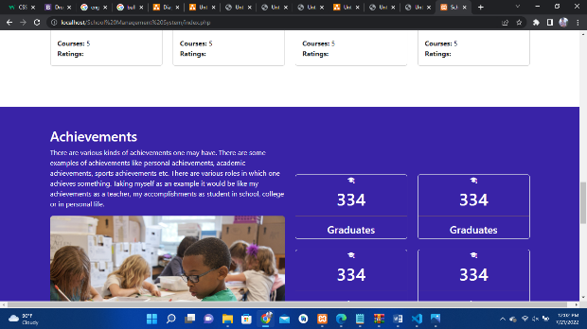 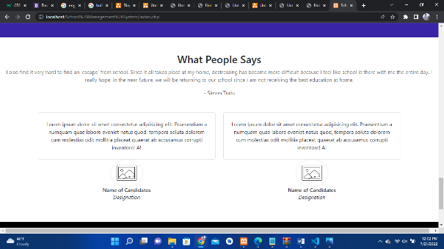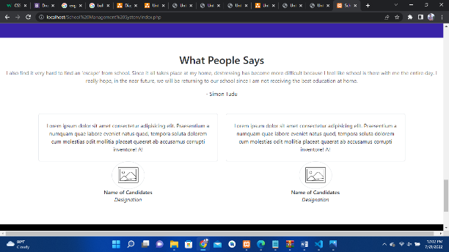 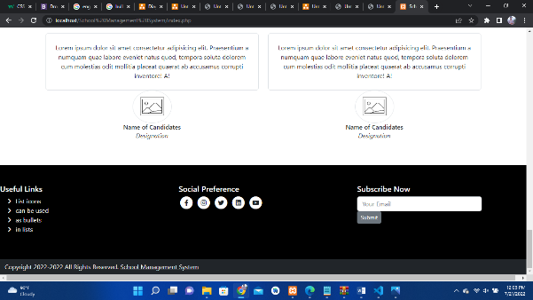

Fig 1.3: Pictures of Home page

Login:

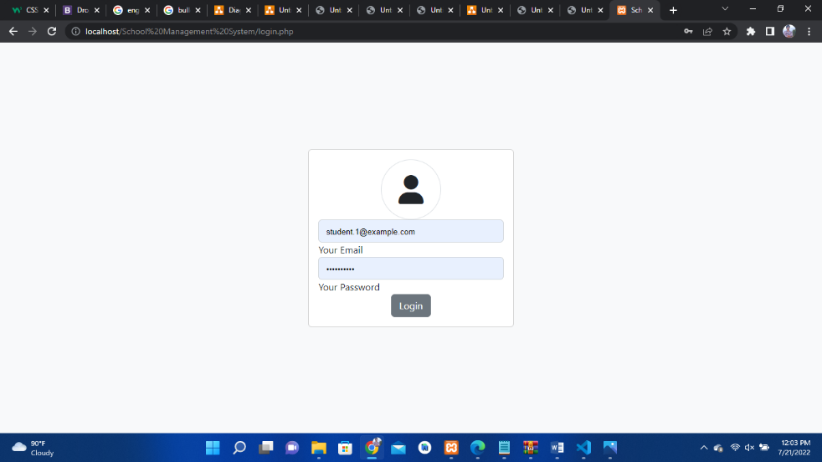

Fig 1.4: Pictures of Login page

Admin Panel :

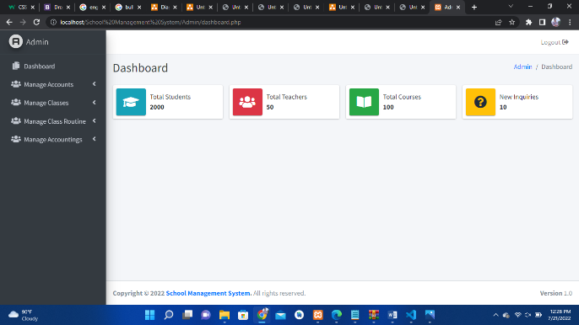 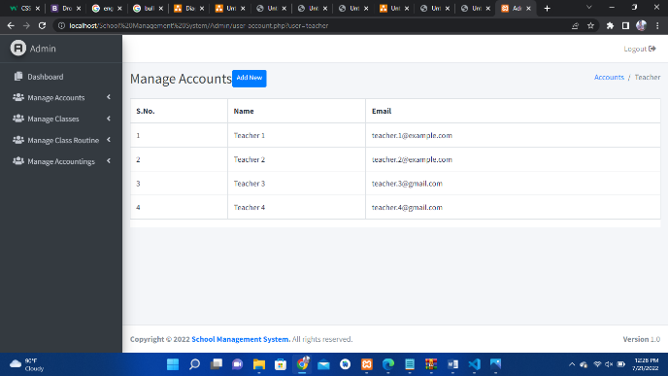

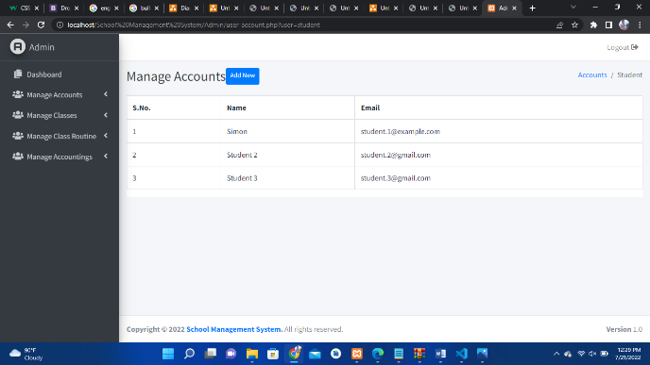 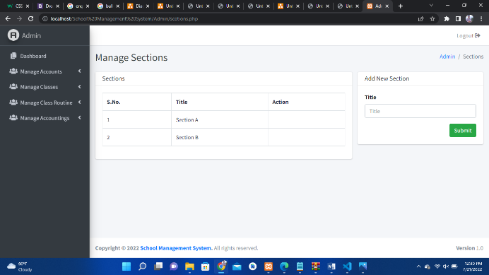

Fig 1.5(a): Pictures of Admin panel

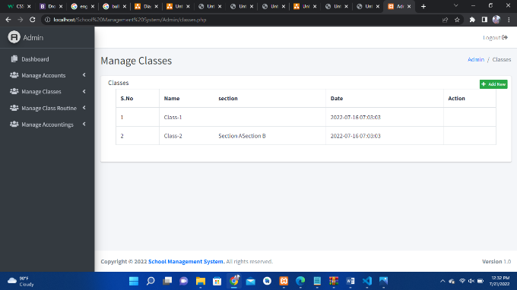 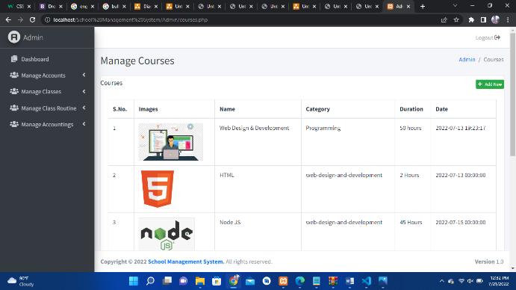

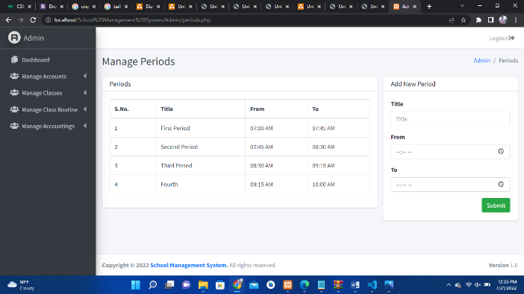 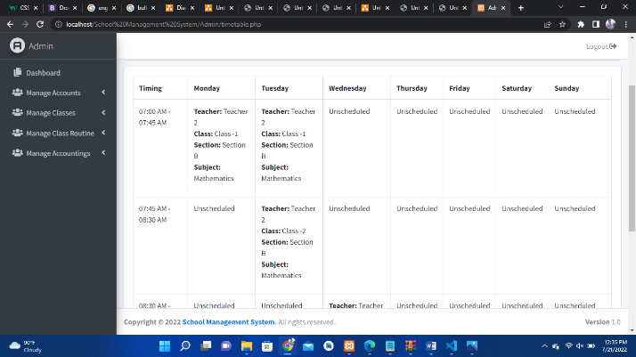

Fig 1.5(b): Pictures of Admin panel

Student Panel:

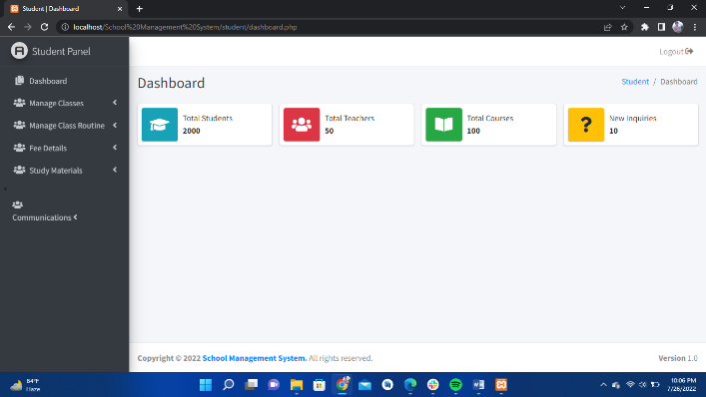 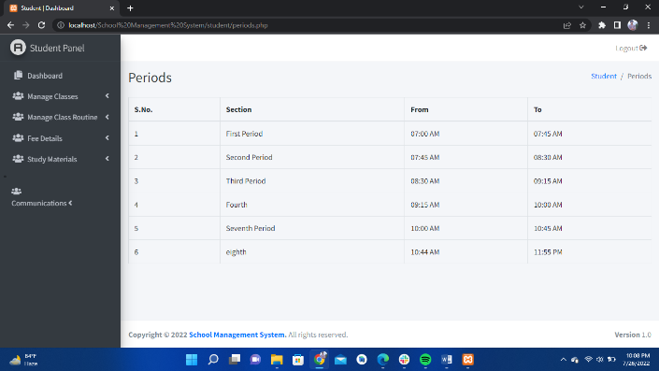

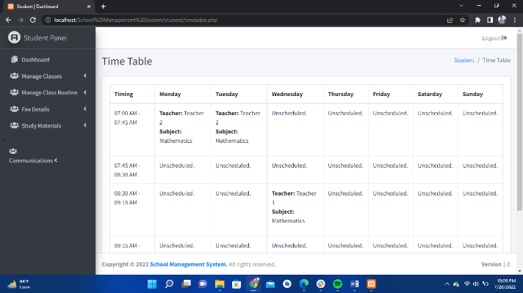

Fig 1.6: Pictures of Student panel

Target vs Actual Accomplishment:

My target was big but my output was little. I want to add more admins such as Parent and Student. In teacher panel I want to add managing students, managing exam marks, provide study materials/files to students, managing attendance etc. In parent panel I want to add get children marks, get children payment invoices, get children class routine, messaging with teachers.

Risk and Issues:

To build this website I faced problems in adding database, to communicate every files to each other, such as header, footer, dashboard, sidebar etc. And also faced problems when I add bootstrap.

Discussion and Conclusion:

I have learnt how to build a website using HTML, CSS, JavaScript, Bootstrap, PHP etc. Learn many CSS framework. I have also learnt about PHP session and cookies. These are very basic and important thing. To be a good developer one’s should know about all things clearly. So I can say that it will be very helpful for my future.

References:

<https://www.w3schools.com/>

<https://www.stackoverflow.com/>

<https://www.youtube.com/playlist?list=PLthQvVh2q_NVWh1gsu5szAkxBG4FGZoVd>

[https://www.youtube.com/](https://www.youtube.com/playlist?list=PLthQvVh2q_NVWh1gsu5szAkxBG4FGZoVd)

https://adminlte.io/